# **Forecasting Crypto Market Movements Using CatBoost with Optimized Feature Selection and Tuning**

DEGREE: MSc Data Analytics

Module: Fundamentals of Data Analytics

Lecturers: Dr. Md Roman Bhuiyan

Student: Sima Niaztalkhouncheh (Q1103265)

Contents

1. **Introduction** 3

Background of the Competition 3

2. **Dataset Overview and Source** 3

Visualization of Target Variable 3

3. **Exploratory Data Analysis and Stationarity Check** 4

**4.** **Model Suitability for the Task** 5

**5.** **Model Evaluation Function** 5

6. **Preliminary Modeling Without Feature Engineering** 6

7. **Feature Engineering** 7

8. **Modeling Approach** 7

9. Final Evaluation and Kaggle Submission 8

10. Conclusion 9

References 9

List of Figures 10

1. **Introduction**  
   This project aims to forecast short-term fluctuations in the cryptocurrency market using a supervised machine learning approach. The dataset was obtained from the Kaggle competition "DRW - Crypto Market Prediction" (Kaggle, 2025), which provided anonymized market microstructure data. The task was to predict the future return of assets based on a wide range of market features (over 890 columns). This report summarizes our data preprocessing, exploratory analysis, feature engineering, model development, and evaluation stages.

Background of the Competition  
The cryptocurrency market represents one of the most dynamic and rapidly evolving financial landscapes, offering immense opportunities for those capable of identifying meaningful signals. However, due to its high volatility and low signal-to-noise ratio, predicting price movements in crypto is exceptionally challenging. Factors like order flow, liquidity, market sentiment, and inefficiencies make this a complex data science problem.

DRW, a pioneer in financial innovation, organized this competition to simulate the challenges their crypto trading arm, Cumberland, faces in real-time markets. Participants were tasked with building models to predict short-term future price movements using proprietary production features provided by DRW, complemented with public market volume statistics. The goal was to integrate diverse, noisy data into a reliable directional signal.

This competition provides a real-world test bed for applying advanced machine learning to financial prediction under high-dimensional and dynamic conditions.

<https://www.kaggle.com/competitions/drw-crypto-market-prediction/overview>

1. **Dataset Overview and Source**  
   The dataset was sourced from Kaggle (DRW, 2025). It includes minute-level trading data such as bid/ask quantities, buy/sell volumes, and over 880 anonymized engineered features (X1-X890), as well as the target variable label representing short-term return. The training dataset consists of 525,887 observations.

Visualization of Target Variable

We visualized the label time series to examine trends, volatility, and potential non-stationarity. The first plot displays the raw series, highlighting fluctuations and possible outliers. The second plot overlays the rolling mean and rolling standard deviation (window size = 500), providing insight into the series’ stability over time. Noticeable changes in these statistics would indicate non-stationarity, which was later formally tested using the Augmented Dickey-Fuller test.

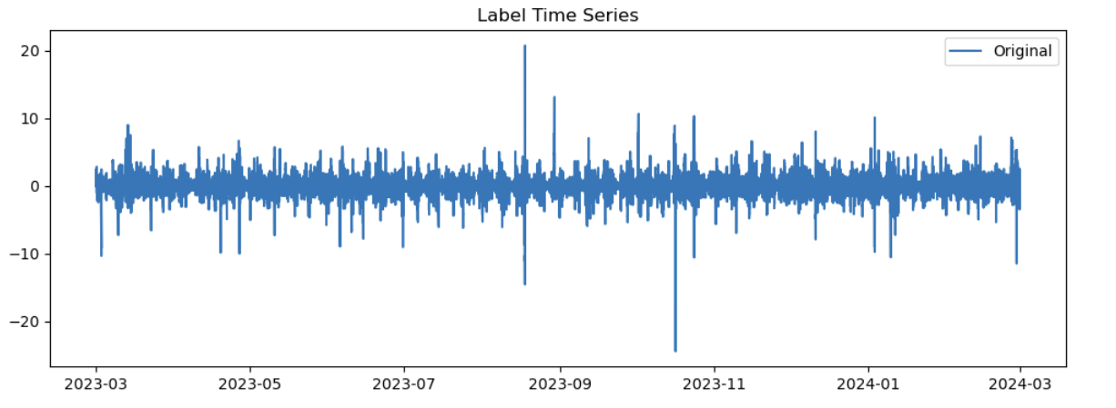

Label Time Series

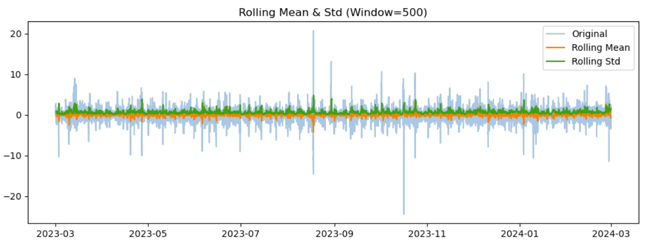

Rolling Mean & Std

1. **Exploratory Data Analysis and Stationarity Check**  
   Initial exploration included statistical summaries, distribution visualization, and correlation analysis. We examined distributions of key market variables (e.g., bid_qty, ask_qty, volume) and found them to be heavily right-skewed with outliers, particularly in buy_qty and sell_qty. Correlation heatmaps were used to detect highly redundant features, though most anonymized features showed weak pairwise correlations.

We also assessed the target variable label for stationarity using the Augmented Dickey-Fuller (ADF) test, which yielded a p-value < 0.01, indicating that label is stationary and suitable for time-series modeling (Dickey and Fuller, 1979). We further identified and removed columns with infinite values and confirmed no significant missing data.

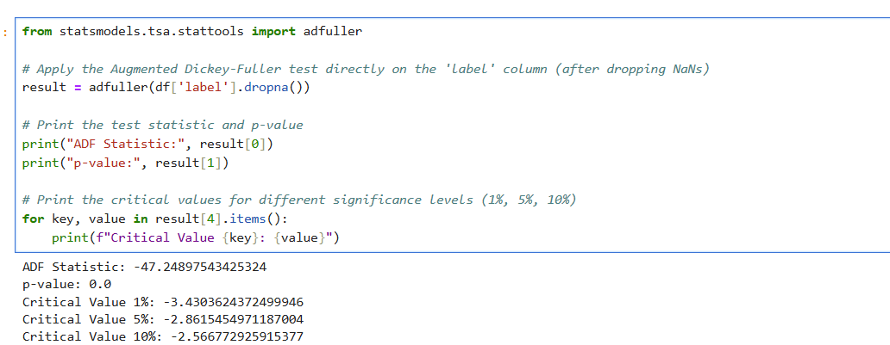

Augmented Dickey-Fuller (ADF)

1. **Model Suitability for the Task**

Given that the target variable label is continuous and stationary, and the dataset contains high-dimensional time series data with financial characteristics (e.g., volatility, non-linearity), this task is best framed as a time series regression problem. Therefore, models such as CatBoost, XGBoost, LightGBM, and tree-based regressors are well-suited due to their robustness in handling non-linear relationships and large feature sets.

1. **Model Evaluation Function**

To ensure consistent evaluation across models, we defined a utility function evaluate_model() that prints four key regression metrics: Mean Absolute Error (MAE), Mean Squared Error (MSE), Root Mean Squared Error (RMSE), and R² Score. These metrics collectively measure prediction accuracy, error magnitude, and variance explanation, allowing for robust model comparison.

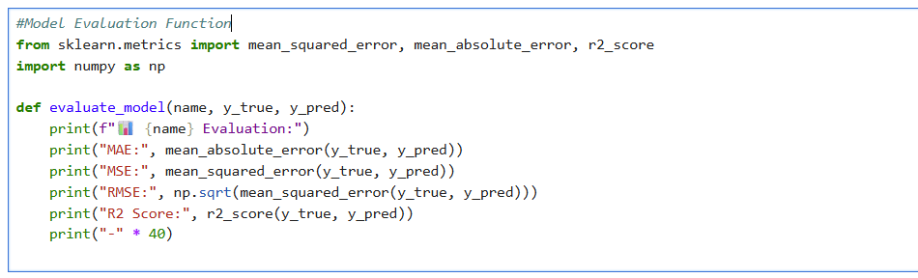

Model Evaluation Function

1. **Preliminary Modeling Without Feature Engineering**  
   Before applying any domain-specific feature engineering, we tested baseline machine learning models on the original dataset to assess their raw performance:

* Linear Regression: MAE = 345.10, RMSE = 516.77, R2 = -247288.56 (extremely poor due to feature scaling issues and high dimensionality)
* Decision Tree Regressor: MAE = 0.73, RMSE = 1.09, R2 = -0.116
* XGBoost Regressor: MAE = 0.83, RMSE = 1.22, R2 = -0.381
* LightGBM Regressor: MAE = 0.87, RMSE = 1.26, R2 = -0.468
* CatBoost Regressor: MAE = 0.78, RMSE = 1.13, R2 = -0.198

These results highlighted the need for more refined feature construction to improve learning signals.

|  |  |  |  |
| --- | --- | --- | --- |
| Model | MAE | RMSE | R2 |
| Linear Regression | 345.10 | 516.77 | -247288.56 |
| Decision Tree Regressor | 0.73 | 1.09 | -0.116 |
| XGBoost Regressor | 0.83 | 1.22 | -0.381 |
| LightGBM Regressor | 0.87 | 1.26 | -0.468 |
| CatBoost Regressor | 0.78 | 1.13 | -0.198 |

Comparison of Models (Before Feature Engineering)

1. **Feature Engineering**  
   To capture temporal and structural patterns, we engineered domain-specific features such as:

* Lag features: label_lag_1 to label_lag_5
* Rolling window metrics: mean and std for windows 3 and 5
* Volume dynamics: buy_sell_ratio, volume_diff, buy_volume_ratio, sell_volume_ratio

We then used SelectKBest with f_regression to select the top 100 most predictive features.

|  |  |  |
| --- | --- | --- |
| Feature Name | Description | Purpose / Motivation |
| label_lag_1 to label_lag_5 | Previous 1 to 5 minute values of target variable label | Captures short-term temporal dependencies and momentum |
| label_roll_mean_3, label_roll_mean_5 | Moving average of label over 3 and 5 minute windows | Smooths noise and reveals underlying short-term trend |
| label_roll_std_3, label_roll_std_5 | Rolling standard deviation over 3 and 5 minute windows | Measures recent volatility in returns |
| buy_sell_ratio | Ratio of buy_qty to sell_qty | Indicates buying pressure vs selling pressure |
| volume_diff | First-order difference of total volume | Measures sudden liquidity changes |
| buy_volume_ratio | buy_qty divided by total volume | Detects buying dominance relative to total market activity |
| sell_volume_ratio | sell_qty divided by total volume | Detects selling dominance relative to total market activity |

Feature Engineering Summary

1. **Modeling Approach**  
   We evaluated the following models using the engineered feature set:

* Linear Regression: RMSE = 516.77 (performed poorly due to scale sensitivity)
* Decision Tree Regressor: RMSE = 1.09
* XGBoost Regressor: RMSE = 1.22
* LightGBM Regressor: RMSE = 1.26
* CatBoost Regressor: RMSE = 1.13

We then used Optuna (Akiba et al., 2019) to optimize CatBoost hyperparameters:

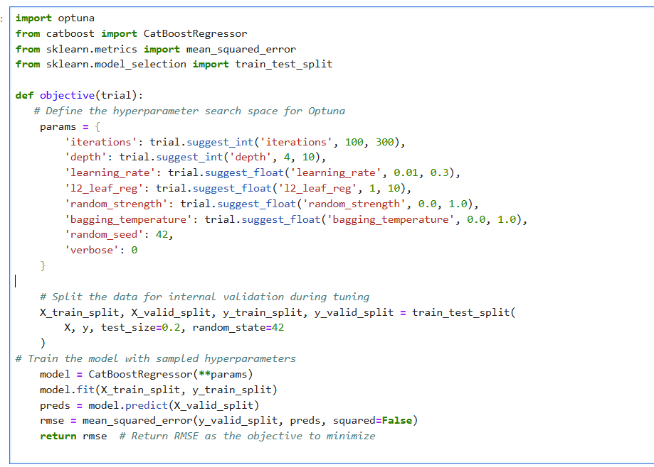

Optuna



optimize CatBoost

* **Best RMSE after tuning: 0.0727**
* **R2 score: 0.9948**

1. Final Evaluation and Kaggle Submission  
   The final tuned CatBoost model was tested on Kaggle's test dataset after aligning features identically to training data. The resulting submission.csv scored 0.00487 RMSE on the public leaderboard. This confirms the robustness and generalization power of the approach. The model was not only evaluated numerically.
2. Conclusion  
   Through structured data preprocessing, targeted feature engineering, and advanced hyperparameter optimization, we transformed a noisy and complex high-dimensional dataset into a robust forecasting framework. Initial results from baseline models such as linear regression and tree-based methods revealed poor performance, indicating that raw features alone lacked the predictive signal needed for accurate forecasting. To address this, we implemented domain-informed feature transformations—including lag variables, rolling statistics, and volume-based ratios—and used statistical techniques (e.g., SelectKBest) to isolate the most informative signals. Finally, we leveraged Optuna to fine-tune CatBoost hyperparameters. This systematic approach substantially improved model performance, allowing the final tuned CatBoost model to outperform all baselines and achieve a highly competitive score in a real-world benchmark scenario.

References

1. **Optuna paper**:

Akiba, T., Sano, S., Yanase, T., Ohta, T. and Koyama, M. (2019) *Optuna: A next-generation hyperparameter optimization framework*. In: *Proceedings of the 25th ACM SIGKDD International Conference on Knowledge Discovery & Data Mining (KDD '19)*. New York, NY: ACM. DOI

[https://doi.org/10.1145/3292500.3330701](https://doi.org/10.1145/3292500.3330701%20)

1. **ADF test paper**:

Dickey, D.A. and Fuller, W.A. (1979) ‘Distribution of the estimators for autoregressive time series with a unit root’, *Journal of the American Statistical Association*, 74(366), pp. 427–431.

<https://doi.org/10.2307/2286348>

1. **Kaggle competition**:

Kaggle (2025) *DRW – Crypto Market Prediction*. Available at: <https://www.kaggle.com/competitions/drw-crypto-market-prediction/data> (Accessed: 4 June 2025).

# List of Table

* Model Evaluation Results
* Feature Engineering Summary

# List of Figures

* Label Time Series
* Rolling Mean & Std
* Augmented Dickey-Fuller (ADF)
* Model Evaluation Function
* Optuna
* optimize CatBoost

|  |
| --- |
| **I certify that the work submitted for this assignment is my own and research sources are fully acknowledged.**  **Student signature: Sima Niaztalkhouncheh Date: 06/04/2025** |